cHyakusenrenma - Front-End Engineers

*Front-end coding test*

Please create a public GitHub repository with the contents of your completed test, and send a link to your contact person at Hyakusenrenma. If you can’t use GitHub, please submit a zip folder with the contents of your test instead. Please complete Steps 1 and 2.

**Step 1:**

Using the following image, please code this section using HTML5 and Sass/Scss.

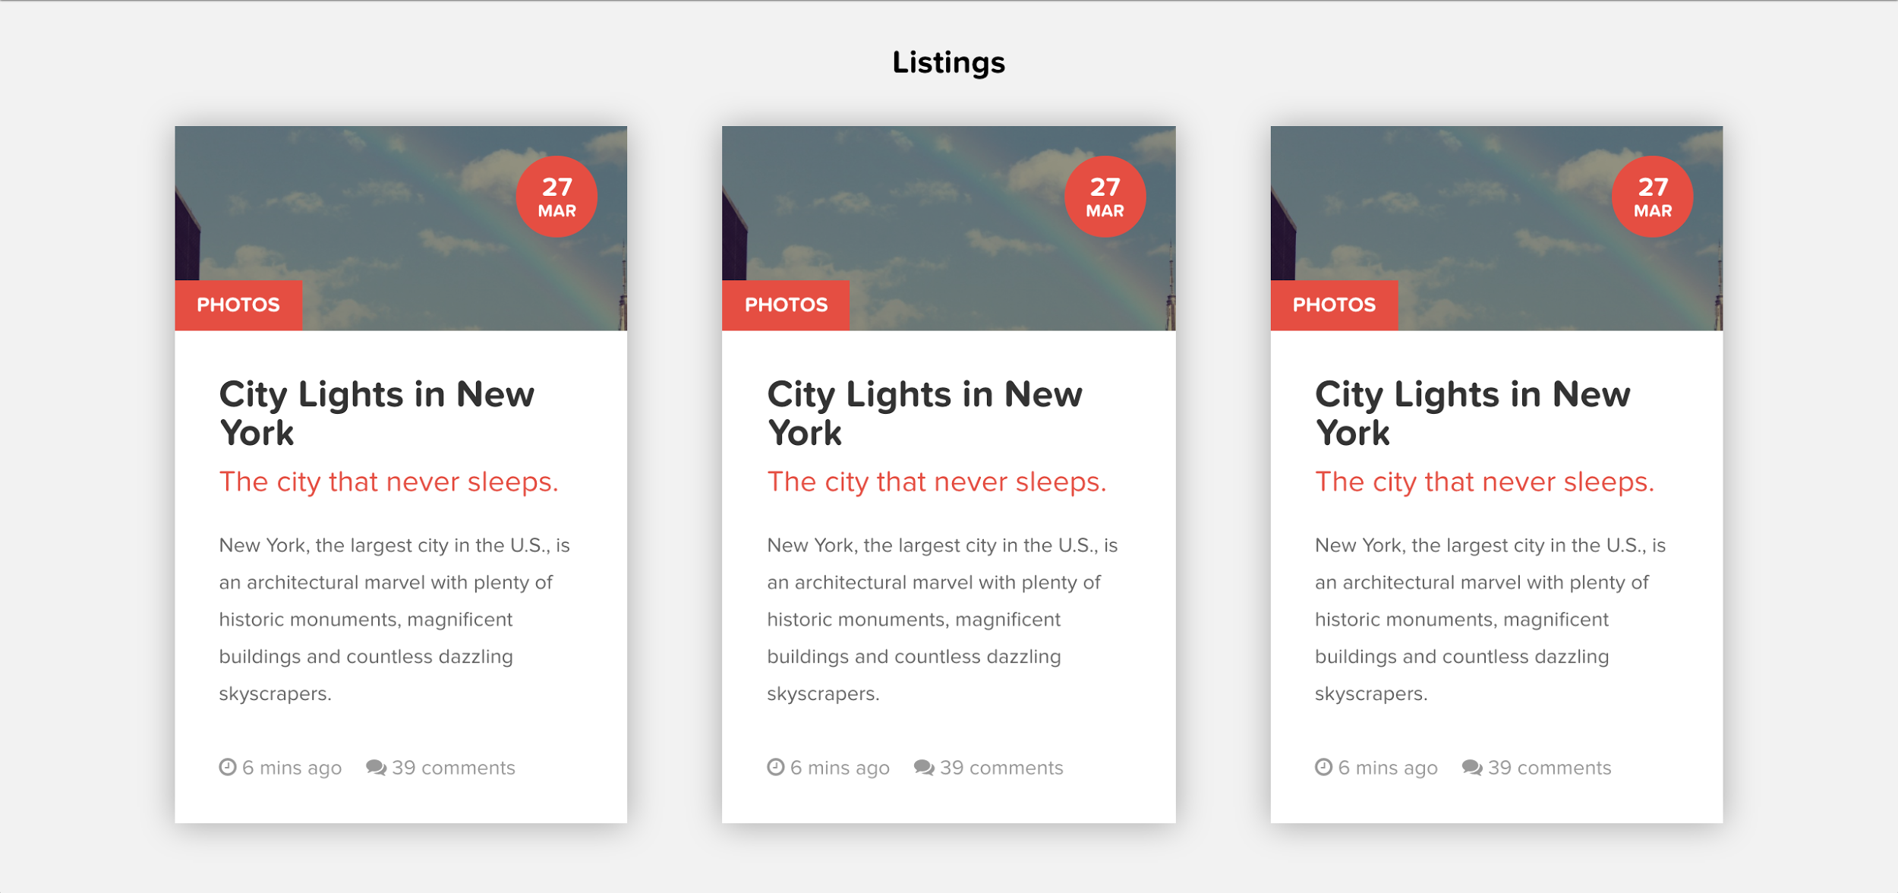

Specifications:

1. Please use *semantic* HTML5.
2. Please use Sass/Scss.
3. CSS should be **responsive**. Styles should be separate. **No inline CSS allowed**.
4. Grid: 1-column for Smartphone, 2-column for Tablet, 3-column for PC.
5. Image can be found here: <https://s3-us-west-2.amazonaws.com/s.cdpn.io/169963/photo-1429043794791-eb8f26f44081.jpeg>
6. For icons, please use <http://fontawesome.io/icons/> (import via CDN)
7. Font family is 'proxima-nova-soft', sans-serif. (import via google fonts)
8. No front-end framework is allowed (Bootstrap, Foundation, etc.)
9. Please consider performance and coding best practices.
10. Please ask questions if you don’t understand anything.
11. You can use other technologies if you like (gulp, grunt, React.js, etc.), but make sure your project builds correctly when submitting it, and be sure it is a scalable solution.

**Step 2:**

Use the _tags.sass file found at the following address:

<https://gist.github.com/eliotc1986/be9ced5c8f0e801f19fe1c7b45b89474>

Specifications:

* Please correct any errors in the Sass code that you find
* Please make any improvements to the code that you would like, based on:
  + best practices
  + style
  + personal preferences
  + etc.
* Please don’t worry about the HTML. (Please assume changes you make to the Sass will be made to HTML as well.)
* You can change class names or code structure if you like.

If you have any questions, please contact Elliott at [hindman@hyakuren.org](mailto:hindman@hyakuren.org)